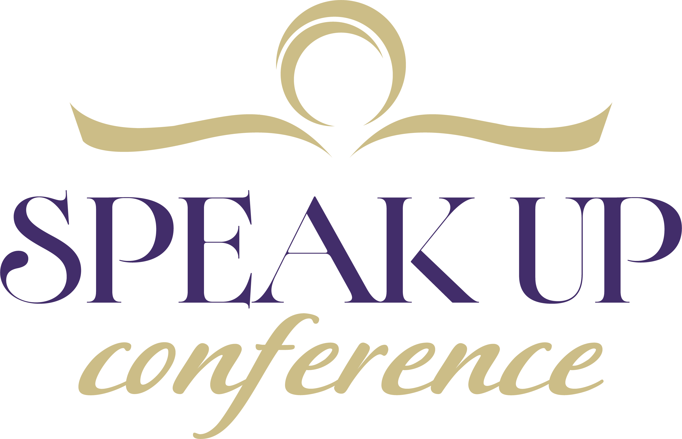
2027 Conference Schedule Overview
Courageous!
Thursday, July 8
9:00-12:00 Pre-Conference Sessions:
Speakers’ Pre-Conference Options:
Design an Encounter (Not a Speech)—Karen Porter
Building a Sustainable Speaking Ministry—Robyn Dykstra
Writers’ Pre-Conference Options: (3-hours)
Book Proposal Intensive Clinic—Dave & Cindy Lambert
10 Steps to Expanding Your Author Platform—Susan Neal
Writing a Transformational Bible Study—Carol Tetzlaff
Ministry Development Option: (3-hours)
Creating & Connecting with Substack—Christy Lynn Wood
The 15-Minute Appointment Lab—Jenn Dafoe-Turner
12:00-12:55 Optional Lunch . . . . . . . . . . . . . . . . . . . . . . . . . . . . . . . . . . . . . . . . . . . . . . . . . . . . . . Great Hall
VIP Lunch. . . . . . . . . . . . . . . . . . . . . . . . . . . . . . . . . . . . . . . . . . . . . . . . . . . . . . . . . . Boardroom
12:55-1:10 Opening Welcome—Bonnie Emmorey & Carol Kent . . . . . . . . . . . . . . . . . . . . . . . .Great Hall
1:10-1:20 Praise & Worship
1:20-2:00 Opening Keynote—Bruce Martin—God-Confidence
2:00-2:45 Panel Discussion: . . . . . . . . . . . . . . . . . . . . . . . . . . . . . . . . . . . . . . . . . . . . . . . . . . . . .Great Hall
Platform Building: Interviews, Podcasts, Social Media & Networking
2:45-3:00 Break
3:00-4:00 Breakout Session #1
(S) Speak Like a Pro (Carol Kent)
(S) Speaker Mistakes to Avoid (Cindy Bultema)
(W) How to Craft a Winning Non-Fiction Book Proposal (Cindy Lambert)
(W) What a Literary Agent Really Does (Debbie Alsdorf)
(P) Podcasting 101 (Linda Goldfarb)
(M) Listen to Connect More Deeply with Your Audience (S&B Harling)
(M) Humor as Healing in Difficult Stories (Cherie Nettles)
4:00-4:15 Break
4:15-5:45 Speakers’ Track—Small Group Critiquing Session . . . . . . . . . . . . . . Location on your printout
Writers’ Track—Introduction of authors with a new book in the last year &
1st Page Peer Critiquing . . . . . . . . . . . . . . . . . . . . . . . . . . . . . . . . . . . . . . . . . . Great Hall
5:45-6:40 Buffet Dinner . . . . . . . . . . . . . . . . . . . . . . . . . . . . . . . . . . . . . . . . . . . . . . . . . . . . . . . . . Great Hall
6:40-6:50 Praise & Worship
6:50–7:30 Evening Keynote— Becky Harling—Courage to Keep Going When You Want to Quit. .Great Hall
7:30–7:45 Break & Sweet Treat (Pick it up and move to your breakout session.)
7:45-8:45 Breakout Session #2
(S) Teaching the Bible with Confidence (Lee Nienhuis)
(S) Maximize Your Speaker Platform (Linda Goldfarb)
(W) Fiction Techniques to Make Your Nonfiction Sing (Joel Armstrong)
(W) How to Get a Publisher (Blythe Daniel)
(P) Reach New Readers through Podcast Interviews (Janet McHenry)
(M) Using AI to Manage & Grow Your Platform (Susan Call)
(M) 10 Revenue Streams for Christian Communicators (Katie M. Reid)
8:55 Sunset Wellness Walk with Dr. Nancy Meyer . . . . . . . . . . . . . . . . . . . . . .Meet in the front Lobby

Friday, July 10
8:00-8:45 (BYO Breakfast)
Breakfast Meeting—A Guided Journaling Experience (Pat Layton)
Breakfast Meeting— Prayer Breakfast (Ginny Davidson & Joanna Tiegan)
8:55 Praise & Worship. . . . . . . . . . . . . . . . . . . . . . . . . . . . . . . . . . . . . . . . . . . . . . . . . . . .Great Hall
9:00-9:05 Welcome, Announcements, & Giveaways—Bonnie Emmorey & Keri Spring
9:05–9:15 Praise & Worship
9:15–10 Morning Keynote—Rachel Wojo—Courageous Prayer
10:00–10:45 Panel Discussion . . . . . . . . . . . . . . . . . . . . . . . . . . . . . . . . . . . . . . . . . . . . . . . . . . . .Great Hall
Current Challenges & Opportunities in a Changing World
10:45-11:00 Break
11:00-12:00 Breakout Session #3
(S) Make Bible Characters as Exciting as a Netflix Original! (Jennie Dimkoff)
(S) Are you Ready to Speak? (Becky Harling)
(W) The Story Steward Method (Athena Dean Holtz)
(W) Your Memoir Can Be the Basis for Your Non-Fiction Book (Shawn Kuhn)
(P) How to Become an Irresistible Podcast Host (Dawn Damon)
(M) Making Courageous Decisions (Jeri Howe). . . . . . . . . . . Trails Behind the Prince Center
(M) Invited to the Table (Jenn Hand)
12:00 Lunch
12:35-12:45 Comic Sketch—Cherie Nettles. . . . . . . . . . . . . . . . . . . . . . . . . . . . . . . . . . . . . . . . . . Great Hall
12:45-1:00 Platinum Sponsors Highlighted
1:00-1:45 Panel Discussion: The Business & Ministry of Speaking & Writing . . . . . . . . . . . . Great Hall
1:45–2:00 Break
2:00-3:00 Breakout Session #4
(S) Your Story Matters: Sharing your Personal Testimony (Angela Donadio)
(S) From Stage to Page (Dawn Damon)
(W) Crafting Your Book to Meet the Felt Need (Rob & Joanna Teigen)
(W) 7 Habits of Intentionally Committed Writers (Carol McLeod)
(P) Being Your Best You (Jennifer Jackson)
(M) Finding & Organizing Your Own Unique Content (Karen Ehman)
(M) Brave Boundaries (Lisa Saruga)

3:00-3:15 Break
3:15-4:30 Speakers’ Track—2nd Small Group Critiquing Session . . . . . . . . . . Location on your printout
Writers’ Track—Lamberts
followed by Q & A with publishers, editors & agents . . . . . . . . . . . . . . . . Great Hall
4:30–5:30 Break
5:30-6:30 Friday Night Banquet . . . . . . . . . . . . . . . . . . . . . . . . . . . . . . . . . . . . . . . . . . . . . . . . . Great Hall
6:30–6:50 Praise & Worship
6:50–7:30 Evening Keynote—Kia Stephens—Writing & Speaking About Hard Topics
In Hard Times. . . . . . . . . . . . . . . . . . . . . . .Great Hall
7:30–7:45 Break
7:45–9:00 Publishing Awards followed by Book Signings . . . . . . . . . . . . . . . . . . . . . . . . . . . . . Great Hall

Saturday, July 11
8:00-8:45 (BYO Breakfast)
Podcasting Breakfast Connection Event (Rachel Wojo & Lisa Granger) . . . . . . Great Hall
Writing to Redeem Your Story (Keri Spring)
8:55 Praise & Worship. . . . . . . . . . . . . . . . . . . . . . . . . . . . . . . . . . . . . . . . . . . . . . . . . . . Great Hall
9:00–9:05 Welcome & Announcements—Bonnie Emmorey & Rachel Wojo
9:05–9:15 Praise & Worship
9:15–10 Morning Keynote— Shannon Popkin—How to Shine Courageously
in a Dark World. . . . . . . . . . . . . . . . Great Hall
10:00–10:45 Panel Discussion—Courageous Faith. . . . . . . . . . . . . . . . . . . . . . . . . . . . . . . . . . .Great Hall
10:45–11:00 Break
11:00–12:00 Breakout Session #5
(S) Aim for Results & Outlining with Pizzazz (Bonnie Emmorey)
(S) Captivate Your Audience (Peg Arnold)
(W) Big Buzz, Small Budget (Maggie Rowe)
(W) Writing Devotions (Sandi Banks)
(P) How to Become a High-Value Podcast Guest (Angela Mackey)
(M) Ministry & Mental Health (Brenda Yoder)
(M) The Network We Need to Succeed (Kathe Wunnenberg)
12:00–12:15 Break
12:15–1:00 Lunch
12:55–1:00 Praise & Worship. . . . . . . . . . . . . . . . . . . . . . . . . . . . . . . . . . . . . . . . . . . . . . . . . . . . Great Hall
1:00–1:05 Introduce Full Speak Up Team
1:05–1:15 Speak Up Masterpiece Theater—Bonnie Emmorey & Gene Kent
1:15–2:00 Panel Discussion: Where Do We Go From Here?
2:00–2:15 Break
2:15-3:15 Breakout Session #6
(S) Presenting & Negotiating Your Speaker Fees (Cindy Bultema)
(S) The Next Level Illustrations (Karen Porter)
(W) Developing a Well-Crafted Christian Living Book (Janet McHenry)
(W) Write From your Scars, Not Your Wounds (Nicole Langman)
(P) Turn One Podcast Conversation into a Content Ecosystem (Dawn Sanders)

(M) Don’t Rent Your Audience: Build an Email List You Own (Rachel Wojo)
(M) God is our Partner (Darlene Larson)
3:15–3:30 Break
3:30-4:30 Closing Session: Praise & Worship. . . . . . . . . . . . . . . . . . . . . . . . . . . . . . . . . . . . . . . Great Hall
Keynote—Carol Kent

See you next year, July 2028

